# Cosc363 Assignment 1 – Alien Invasion!

Kyran Stagg

78943881 – kst84

## Scene Description

Upon opening the scene, the player is shown a fortress made out of glutSolidCubes that have been repeated recursively to create the walls. Inside the fort is a UFO spaceship with a spinning animation to enhance the levitating effect it shows. The ship is made from glutSolidSpheres. The player can look around and see two cannons outside the fort. These were created in lab 2 from .off files and glutSolid objects. Pressing the ‘c’ button will fire the cannon balls to deter intruders. Outside the fort there are two distinct robots patrolling. These robots are made from glutSolids and one has a textured face. The skybox makes the scene feel like it is night time and the floor is made from a cobblestone texture.

## Screenshots

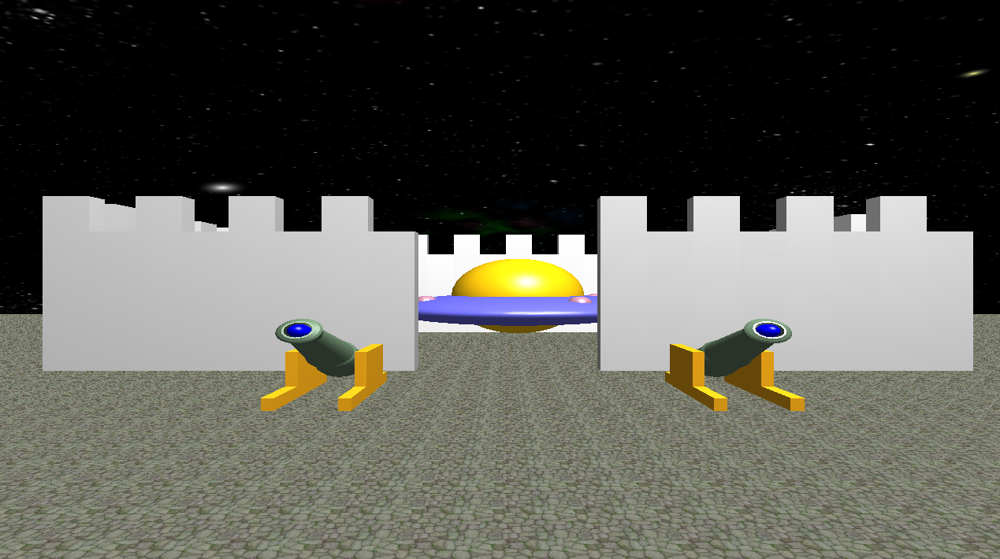

*The front of the fort showing the UFO and cannons*

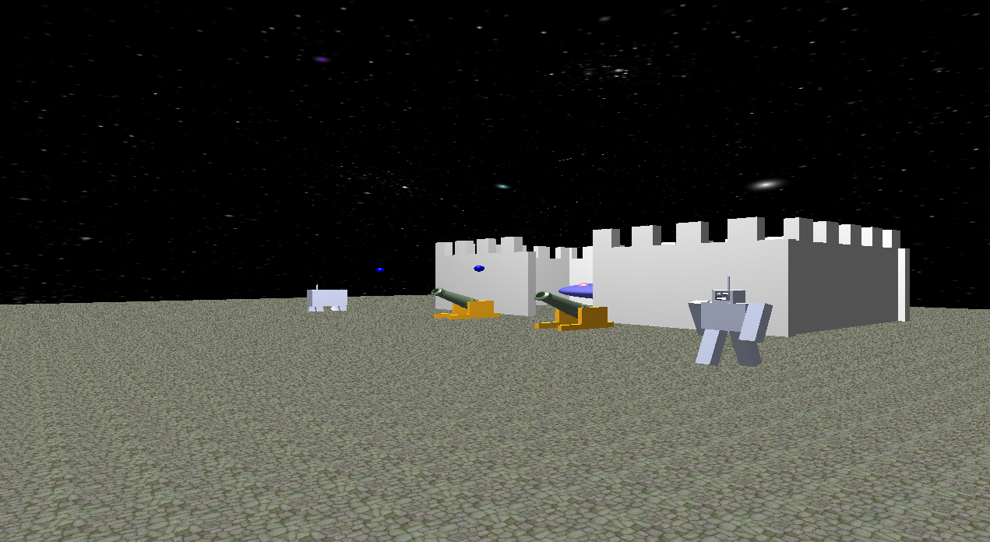

*Further away from the fort with the robots shown and with the cannons firing*

## Extra features

The cannons have a parabolic firing trajectory to simulate gravity and its effect on the moving cannon ball. When the x value of the cannon ball is incremented the y value is calculated with the equation:

Also the cannons cannon be fired while the cannon balls are moving and the cannon balls stop when they hit the ground allowing them to be reloaded

There is collision detection when a player tries to walk off the map. When a player gets too close to the edge they are teleported back to the center of the map.

The scene uses a textured skybox of a night sky to show its night.

Robot 2 has a working spotlight but unfortunately when the floor texture is turned on it isn’t visible. With a colored surface it is visible.

Challenges

During development, writing all the code in one class was difficult and got very cluttered. I took significant time to figure out how to use modular files and headers. This helped me organize my work space and debug more efficiently. Texturing the floor quads correctly was also a challenge. I had an issue where multiple textures would overlap and make the floor look distorted. Trial and error were the only way to fix this problem. I also had trouble with my camera clipping into objects when you weren’t close to them. This was fixed by moving the back lens as close to 0 as possible. There was also a problem where the spotlight wouldn’t work when the floor is textured but only when it is a solid color.

## Controls

Up arrow: Move the camera forward

Left arrow: Turn the camera left

Right arrow: Turn the camera right

Down arrow: Move the camera back

S: To initiate the UFO spaceships lift off

C: To fire the cannons

## Texture Sources

Skybox: AME_NEBULA from <http://www.custommapmakers.org/skyboxes/zips/ame_nebula.zip>

Floor: ground_01.png from <https://opengameart.org/content/tileable-bricks-ground-textures-set-1-ground01png>

Robot: Created by me